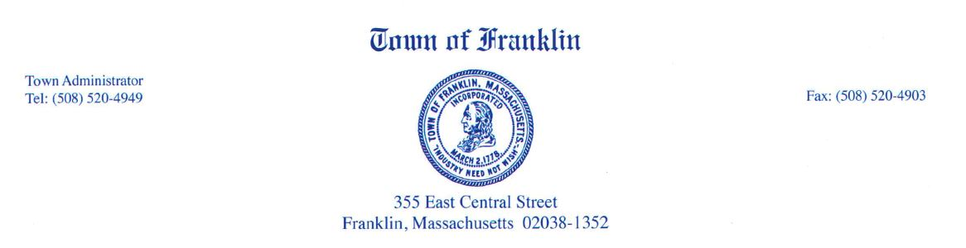

Economic Development Subcommittee Meeting
April 26, 2017
6:00 PM
Room 205

Agenda

- Agricultural Commission Presentation & Discussion

