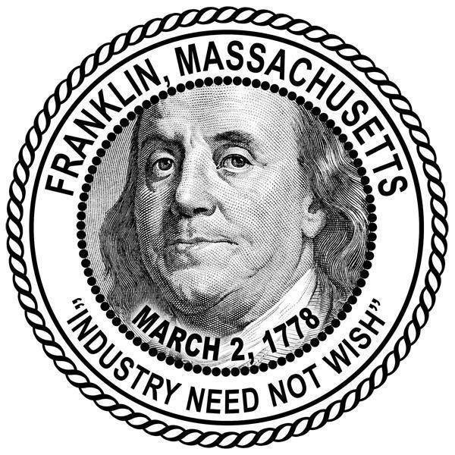
FRANKLIN AGRICULTURE COMMISSION
Agenda & Meeting Packet
July 25, 2022

Meeting will be held at the Municipal Building
3rd floor, Training Room
355 East Central Street
7:00 PM

A NOTE TO RESIDENTS: All citizens are welcome to attend public board and committee meetings in person.
In an effort to maximize citizen engagement opportunities, citizens will be able to continue to participate remotely via phone OR Zoom.

Link to access meeting via Zoom for July 25, 2022 Agriculture Commission Meeting:
- Zoom Link HERE -- Then click “Open Zoom”.
- Or copy and paste this URL into your browser: https://us02web.zoom.us/j/81503617450
- Call-In Phone Number: Call 1-929-205-6099 and enter Meeting ID # 815 0361 7450 --Then press #

Agenda

- Guest speaker Breeka LÍ (bree-kah lie) Franklin’s new Conservation Agent who is versed in Ag Exemptions as they relate to the WPA - also a wetland scientist. Breeka would like to introduce herself and present some noteworthy Ag exemptions to the committee, and perhaps answer any questions we may have? I look forward to hearing from her and building a working relationship with the conservation department and farming in Franklin.
- Chapter 61 mailing goal for August. Is everything ready? Chapter 61 pamphlet has been obtained. Farm listing flier has bebe printed? Agricultural cover letter final approval has already been received, and will be printed?
- Possible August speaker is forester Tom Farrell who will speak regarding a forester plan and how it can relate to chapter 61.
- 2021 recap of goals and accomplishments for yearly report

