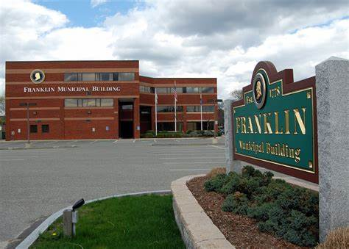
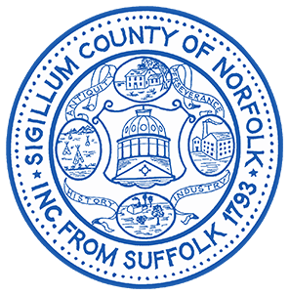
Register O’Donnell and his staff are able to provide residents with certified copies of land documents, such as deeds and homesteads. In addition, Registry personnel are able to confirm whether or not a mortgage discharge had been recorded for mortgages that have been paid off. Finally, staff was able to bring original land documents for residents back to the Registry for recording.

Norfolk County Register of Deeds William P. O’Donnell
-------------------------------

Office Hours

Franklin
-------------------------------
Tuesday, May 7, 2024
10am-12pm
Franklin Town Hall
Council Chambers
355 East Central Street, Franklin
“These Registry Office Hours allow us to bring the Registry of Deeds directly to the residents of Norfolk County without needing to travel to the Registry’s central office in Dedham.”  – Norfolk County Registry of Deeds William P. O’Donnell | Homestead Act  Completed Homestead forms will be taken back to the Registry for recording.  Help Locating Land Documents Staff will be present to help look up land documents such as a recorded homestead, deeds, mortgages, and mortgage discharges.Certified Copies Obtain certified copies of land documents, such as deeds and mortgage discharges.

