2023 Dog Licensing

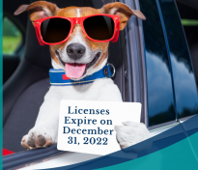
Time to Renew Your Dog License.
Renew Online, By Mail or at Town Hall.

Town of Franklin

2023 dog licenses are now available from the Town Clerk's Office. Current dog licenses expired on December 31, 2022. Please be sure to register your dog prior to the deadline of April 1st to avoid late fees. Dog license fees are $20 for a spayed/neutered dog or $30 for an intact dog.
Registration process:
ONLINE: Dog owners can renew the dog licenses online at https://franklinma.viewpointcloud.com. Please update all information and upload a new rabies certificate if needed.
MAIL: Submit a completed request form including all dogs in the household, along with a copy of current Rabies certificate(s), proof of spay/neuter, and a self-addressed stamped envelope. Please make checks payable to the Town of Franklin.
IN-PERSON: Dog owners can renew the dog licenses at the Town Clerk's Office, at 355 East Central Street.
Please inform this office if you no longer own a dog so we may keep our records up to date. Lastly, kennel licenses are required for owners of four or more dogs.
If you have any questions, please call 508-520-4900 or email, townclerk@franklinma.gov

